<https://www.youtube.com/watch?v=pCK6prSq8aw&t=5s>

1. Sequence Diagrams are a type of UML diagram that show how objects in a system or classes within code interact with each other.
2. Particularly these diagrams show interactions in the order, they take place.  
   In other words, they show the **sequence of events**.
3. They are primarily used by developers and business professionals to document processes or understand the requirements of a new program.
4. First we need a topic to start making sequence diagram.
5. For example, let’s **diagram interactions** thathappen at an ATM.
6. The first step is to think of the parts that make up whatever your topic is.
7. **For example**:
   1. If you’re diagramming a system, that would mean all the parts of that system.
   2. If you’re diagramming code, that would mean all of the classes that make up the program.
8. So in our case what are the parts involved in an ATM transaction? Here Transaction is a set of interactions.
   1. A person goes to an ATM to get money.
   2. The ATM communicates with a bank server and that person’s bank account is then accessed.
   3. The **ATM**, **bank server** and **bank account** are all a part of the ATM system.  
      These 3 items are objects.  
      The Person on the other hand is external to the system.
   4. 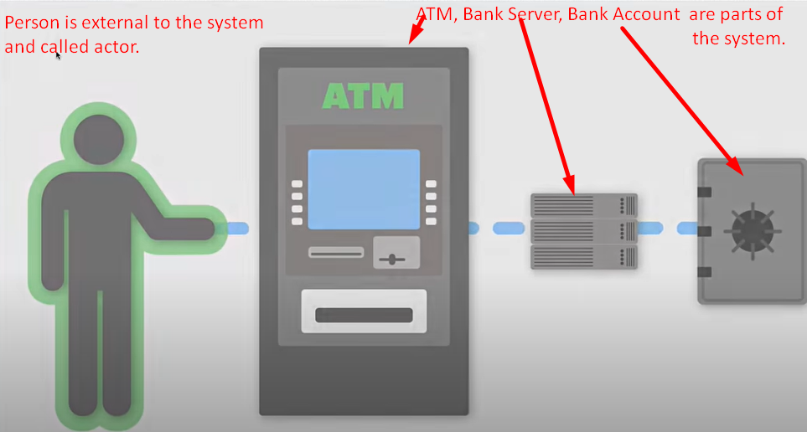
9. 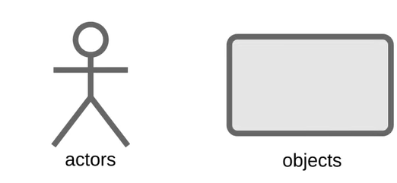
10. Person trying to get money.

Lifelines are vertical dashed lines that show the existence of an object or actor over time?  
Moving down the lifeline means that more time is passing. So, we will drag out a lifeline for the actor and for each of our objects.

We can diagram the interactions b/w the actor and our objects.

Now think about all steps that happen when you go to get cash at an ATM.  
Message: The first thing you do is to insert your ATM card which is called msg.

Messages show the information being sent b/w objects.   
Sequence diagrams show the order of the interactions or sequences and they do this by moving down the life line with each message.

Label on interaction which is represented by a directed line from the lifeline of an actor to the lifeline of an object.

**Return/Reply Message**: When an object returns message back.

It is represented by dashed directed line.

“Request Pin” is not represented by dashed line as this is not a reply to a message but requesting for info.

What happens when the card is invalid like when an inserted card is expired?

This is where “**Alternative Frame**” comes into picture.

Alternative frame symbolizes a choice b/w two or more message sequences.

These choices are usually mutually exclusive. So in this case the conditions are if the card is valid or it is not.

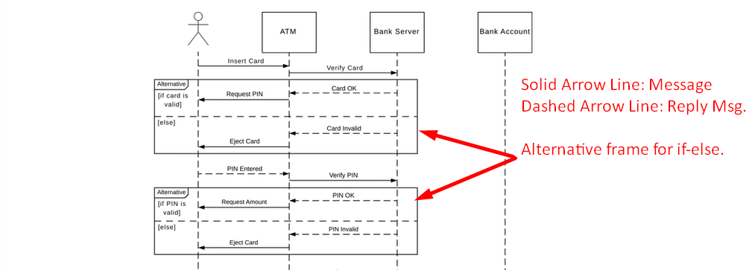

1. We continue to map out the rest of the interaction by creating message and return messages until the transaction is complete and the actor has received their money.
2. 